1770 S Overland
Juniata NE 68955
(402) 756-5121
Creation1@juno.com
www.Creationinstruction.org

“Since the Creation of the World, God’s invisible qualities, His eternal power and Divine nature have been clearly seen, being understood from that which has been made so that men are without excuse “ (Romans 1:18-10)

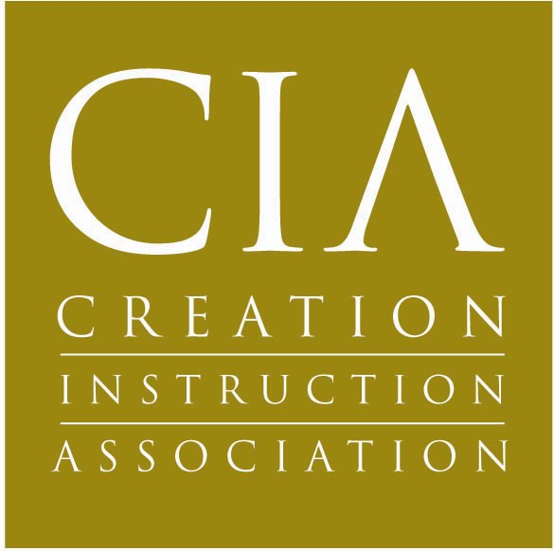

***************************************************************************************

ISLAM AND ANTICHRIST DVD WORKSHEET

- How many Muslims were on the earth in 2011? ______________________What are the numbers projected for 2030 ____________________?

- What does Islam mean____________________________________________________________?

- When was Muhammad born and where? ____________________ ________________?

- Which supposed angel appeared to Muhammad and gave him revelations? ____________________________? How was this angel described?____________________.

- How did Muhammad get to Jerusalem__________________________________________?

- Why is the Dome of the Rock so important? _____________________________________________________________________________________

- Why is Ezek 28 significant where Satan said he would ascend to the throne of God? _________________________________________________________________________________________

- Why was Muhammad initially persecuted? _________________________________________________________________________________________.

- Where did Muhammad flee to for 8 years? ________________________________________

- What is the Ka’bah and where is it located? ______________________________________

- The two main divisions of Islam are the Sunnis and the Shi’ites. Circle the one that is the minority and describe the difference between the two:
SHI’ITES _______________________________________________________________
SUNNIS ________________________________________________________________
- Why is the Battle of Tours in France so important? _________________________________________________________________________________

- What word is used for military conquest or the spread of Islam by the sword? ____________________________.

- What is different between early teachings of Islam verses later teachings after they returned to Mecca? ___________________________________________________________________________________

- Who are the People of the Book? _____________________________________________

- List three differences between Allah and God. A)____________________________________B)____________________________C)______________________________________________

- What do they call the unforgivable sin of attaching God’s qualities to Allah? ________________________________

- List two Bible verses that shows God loves sinners __________ ____________________________________________________

- List a Bible verse to show God is a fatherly figure, which is opposed to Islam ____________________________________.

- Who is Jesus to a Muslim? _________________________________________

- List four of the five reasons to reject Islam. A) ________________________________ B) ________________________________C)_______________________________________D)____________________________________________________________________________________________________

- What is the most important thing to emphasize when witnessing to a Muslim? ___________________________________________________________________________

- List four similarities between the Biblical Antichrist ant the Mahdi A)______________________________B_________________________________________C)_______________________________________________D)________________________________________________

- Which Bible verse says an evil image will speak? ______________________________

- Which Bible verse speaks of Satan falling as a star? ___________________________

- Which Surah speaks of Allah as a star? __________________________________________

- Why is Revelation 20:4 significant in the discussion of Islam? _______________________________________________________________________________________

- What does Revelation 13:11 have to do with Islam? ______________________________________________________________________________________

- What did Gideon take from the necks of the camels of Midian? ___________________Why is that significant? _______________________________________

- How does Islam view deception? ______________________________________________

- What is suppose to happen when countries reach 100% Muslim population? _____________________________________________________________________________________
Does this reflect what we see with nations that are 100% Muslim today? _____

.

ISLAM AND ANTICHRIST DVD WORKSHEET
ANSWER KEY

- 2.2 Billion in 2011 and 8.3 billion projected by 2030.
- To Submit or Surrender.
- 570 AD Mecca (Saudi Arabia today).
- Gabriel. Angel of light like a peacock with glittering jewels.
- Heavenly horse.
- Dome of the Rock is where Muhammad supposedly ascended to heaven.
- Satan wanted to ascend to God’s throne and it is said that Muhammad did so. The Antichrist does everything Christ did, but as a counterfeit.
- He was promoting monotheism (one god).
- Medina.
- Main sanctuary in Mecca.
- Sunnis: Successors are elected. Shi’ites: successors must be related. Shit’ites are the minority.
- They stopped the advance of Islam. Some believe Europe would have been Islam if they had not.
- Jihad
- Early teachings were more docile while later teachings were must more hostile towards non-muslims.
- Christians
- No trinity, has no son, does not love sinners.
- Shirk
- John 3:16, Rom 5:8 shows God’s love for sinners.
- Rom 8:15, Eph 1:5, Mat 6:9 shows God as a Father.
- Just a prophet.
- Contradicts teaching of salvation by grace, not works, Contradicts Science, Contradicts History, Internal Consistencies, No good reason to support it.
- God’s love and grace. They don’t understand an intimate relationship with God so stress that.
- Head of world government, world religion, makes 7 year treaty with Jews, rules 7 years, comes on white horse, invades Israel, rules from Jerusalem, persecutes Christians, changes laws and times, has a false prophet, has supernatural powers, comes at a time of war.
- Rev 13:15
- Rev 9:1, 8:10
- Surah 24:35-36.
- Muslims behead the infidel as revelation says happens to Christians.
- Surah 27:82 tells us a beast will emerge out of the desert which the Bible describes as an evil person, yet Islam sees it as a Messiah figure.
- Crescent ornaments, the sign of Islam today.
- As a good thing. Allah was the Greatest of deceivers so they use it as a weapon of war. It is encouraged to lie to deceive the enemy until they are strong enough to overcome.
- Peace. Not at all.

